NAME : NISHITA MANAHRSINH SOLANKI

ROLL NO.: 22BCE211

SUBJECT : CN AND DEVOPS

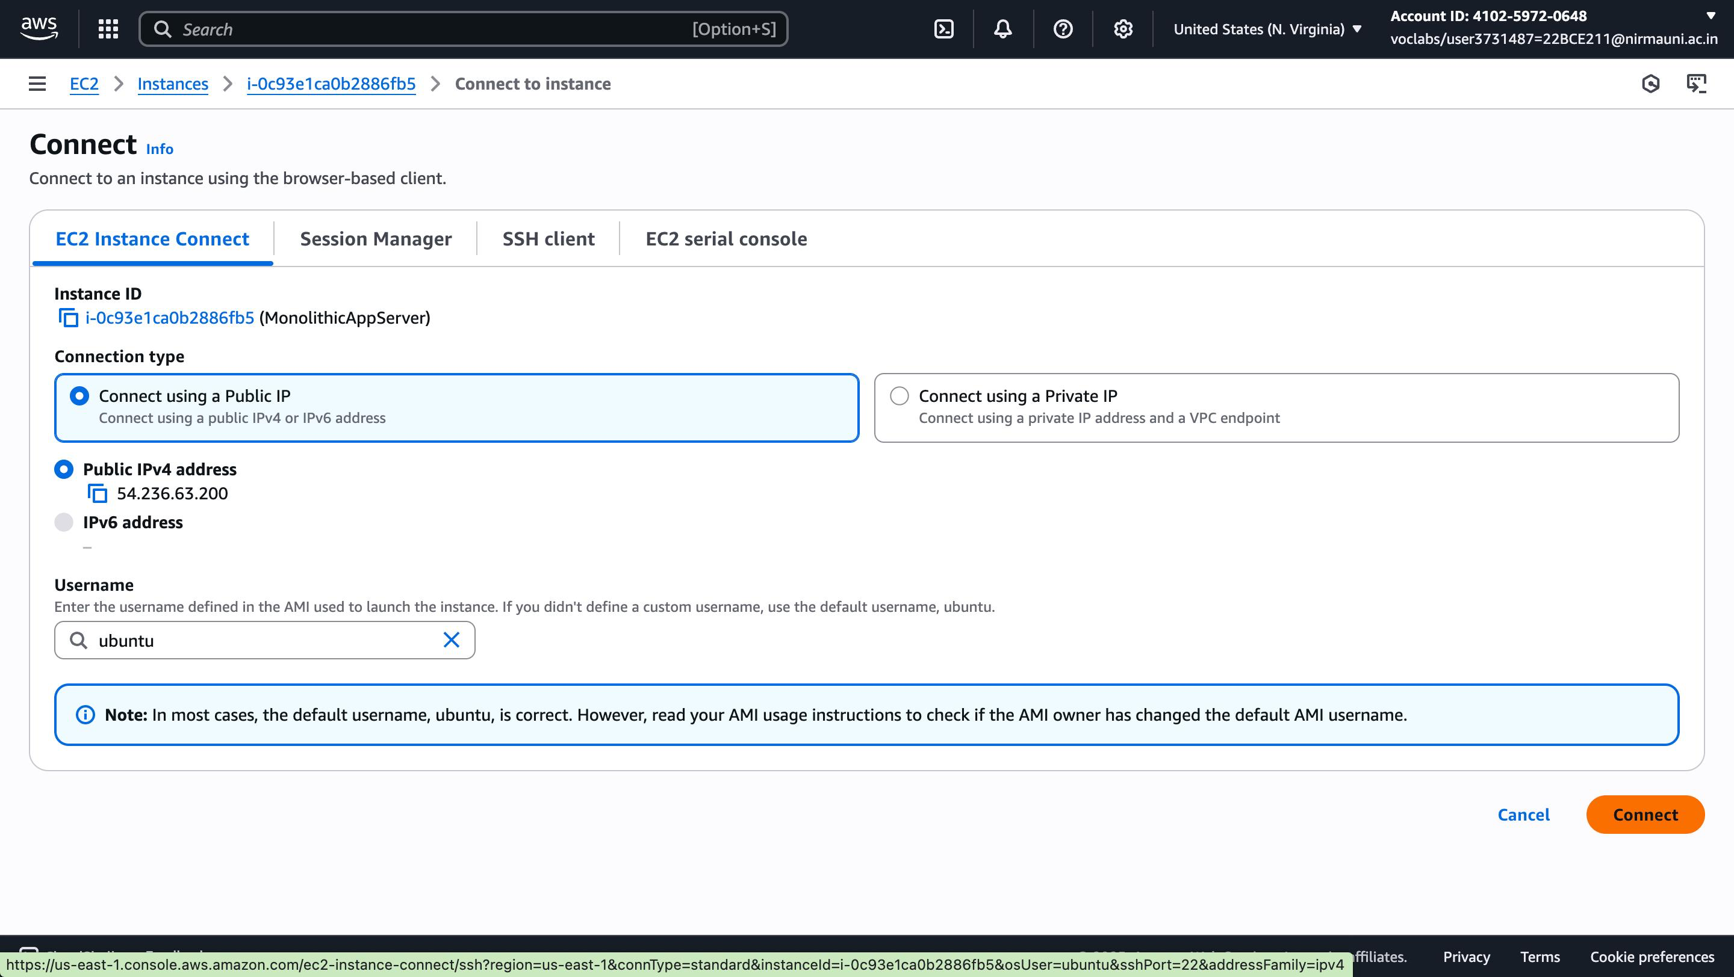

Git clone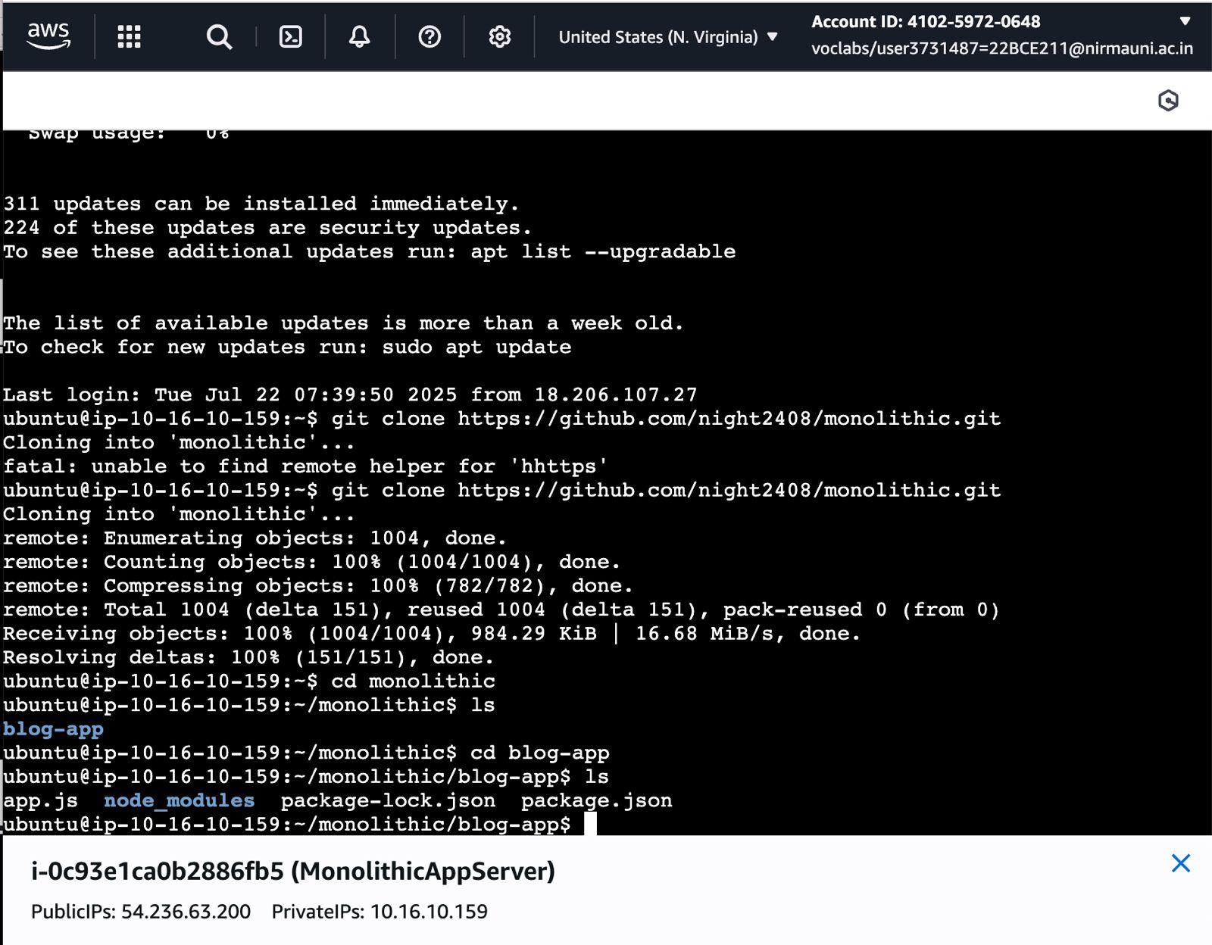

Sudo apt install nodejs npm

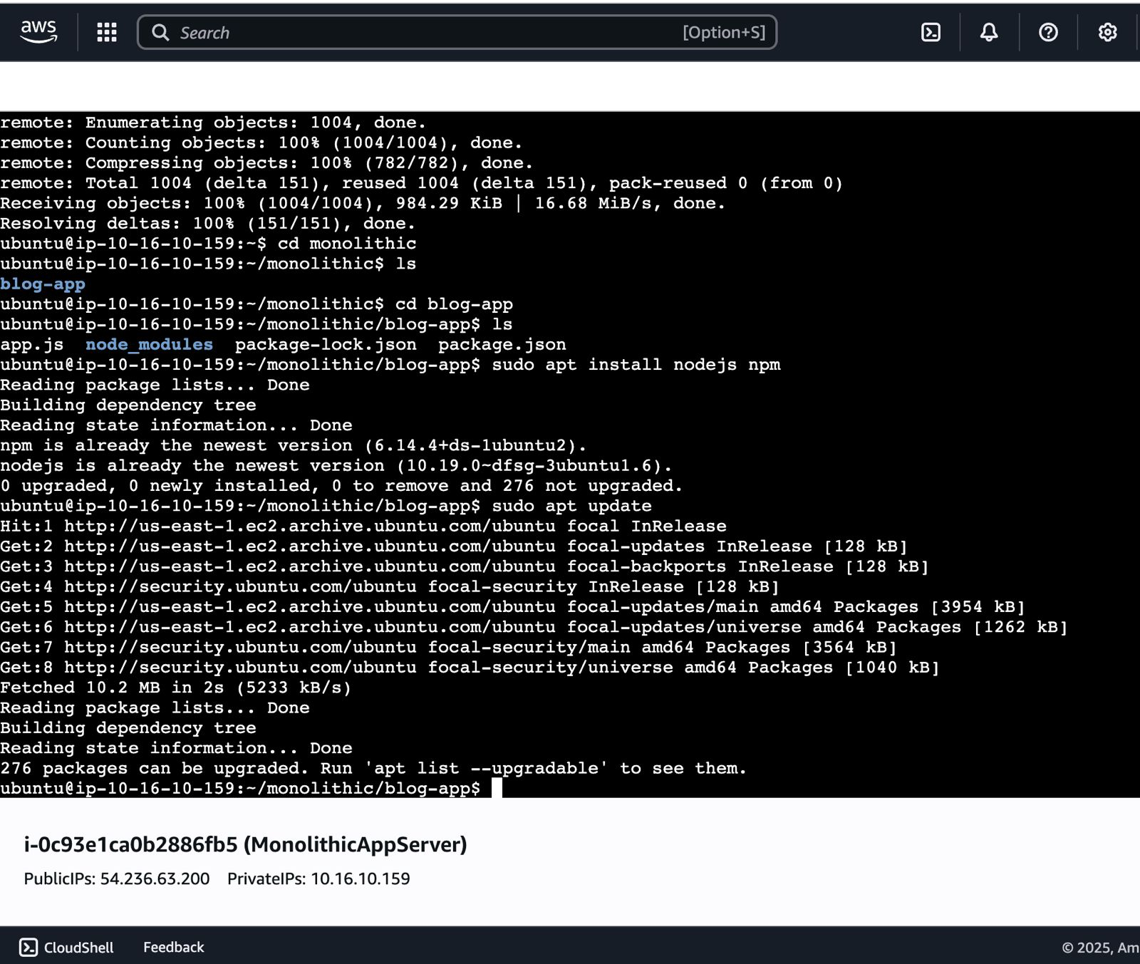

Checking version – node -v / npm -v

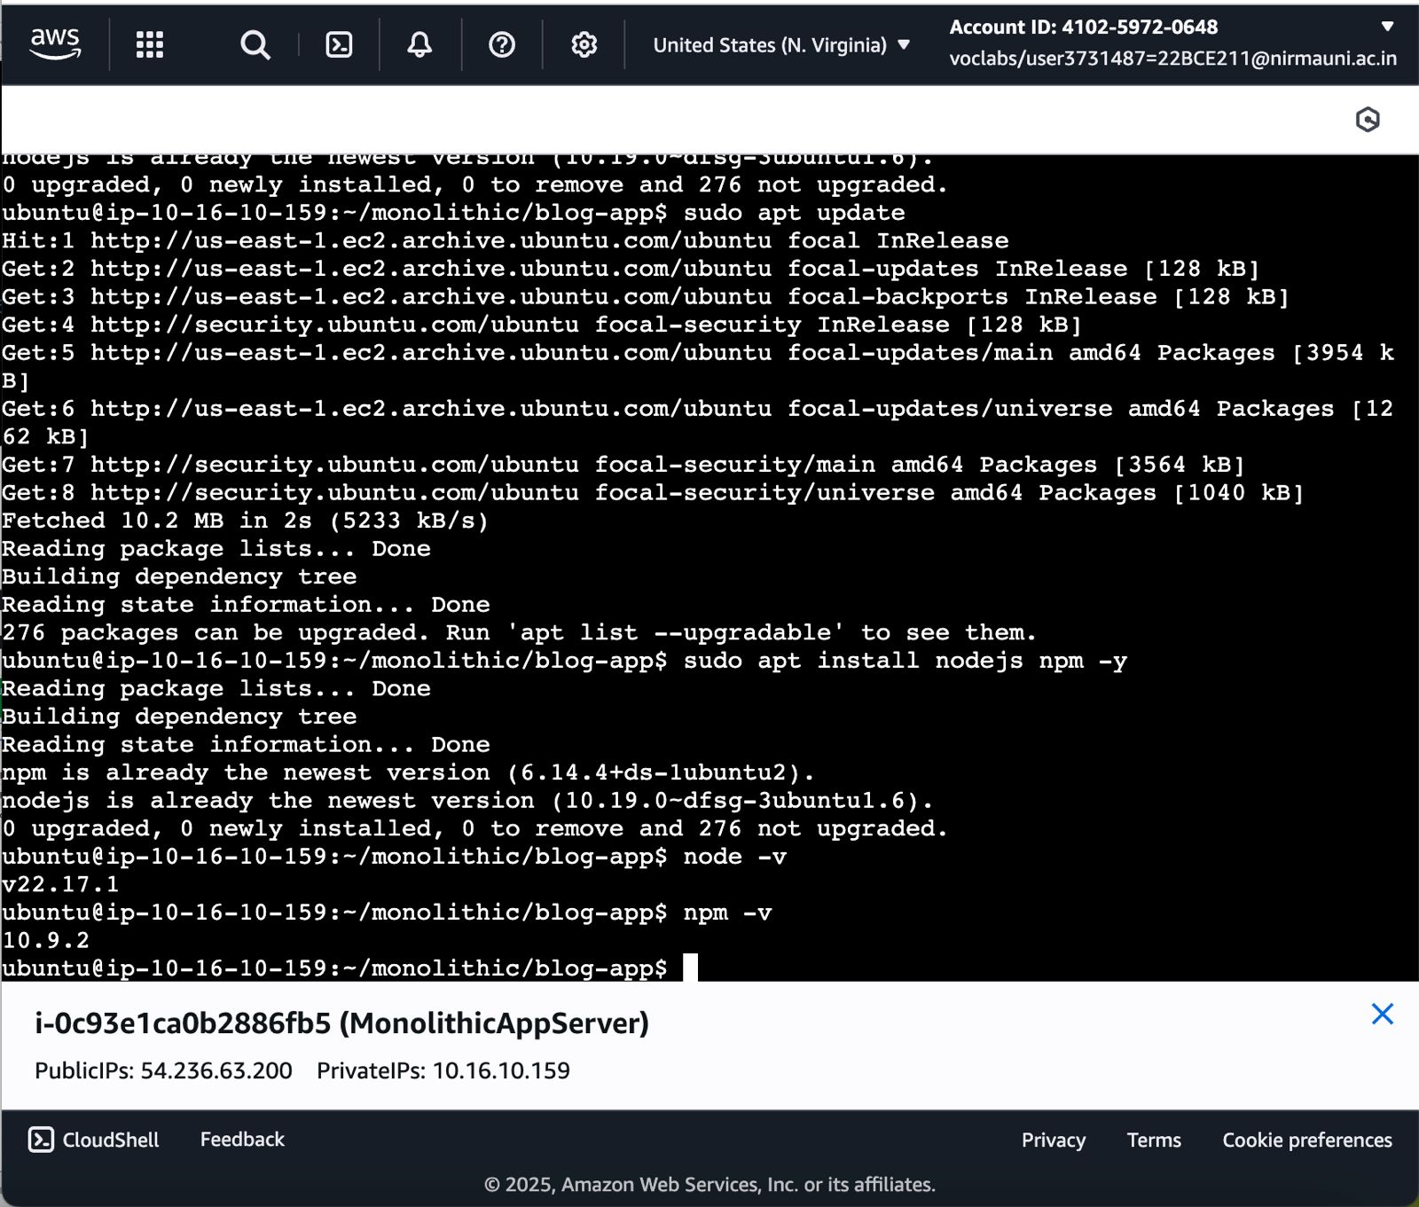

Setting security groups

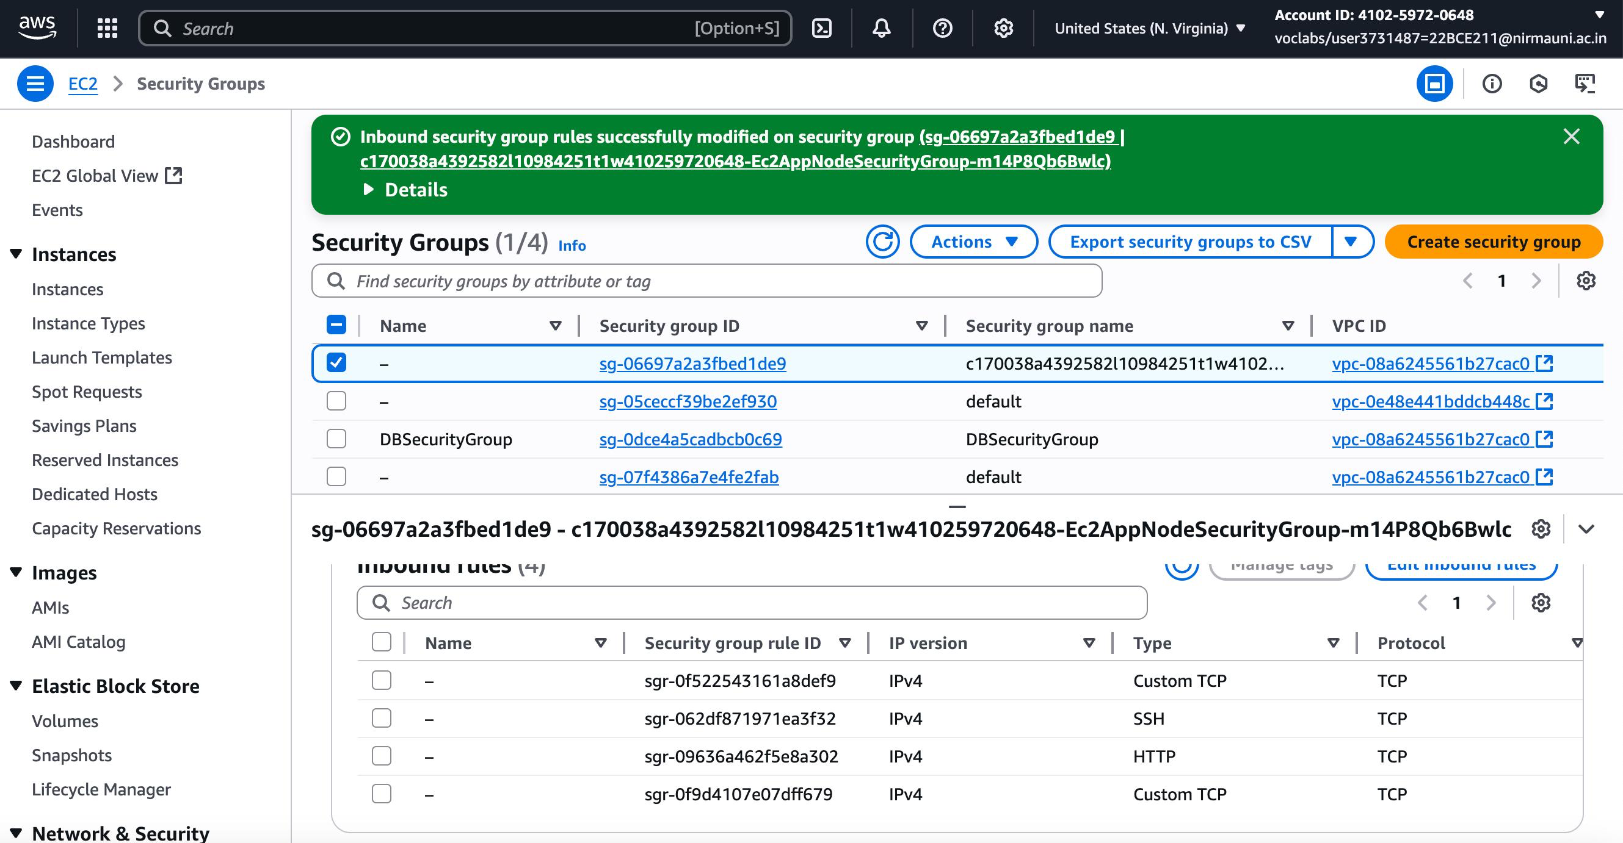

Running services